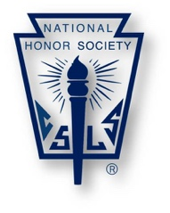
Name: ______________________________ Grade: _____

2021- 2022 NHS Member Service Hours Record Form
To maintain membership in the National Honor Society, juniors/seniors are expected to complete and document a minimum of 15 service hours between the dates of May 1, 2021 and April 30, 2022. It is best to record these hours throughout the year and have a sponsor sign to verify your work in a timely manner.
Feel free to use additional forms if you require more space to record activities.
Please remember you may not receive any compensation or academic credit for your service hours to qualify.
Activities performed as a part of regular duties/participation in other clubs do not qualify for NHS.
This form must be completed and submitted on or before May 1, 2022, to Mrs. Gibson.
Description of Service Activity | Number of Hours | Sponsor Signature | Sponsor Contact Information

I hereby state that the above records are true and accurate representations of my volunteer efforts.

_____________________________________________ ___________________________
Signature Date

